RUC, September 2006
Quantum Chemistry & Spectroscopy.

X Jun 2004 (1)

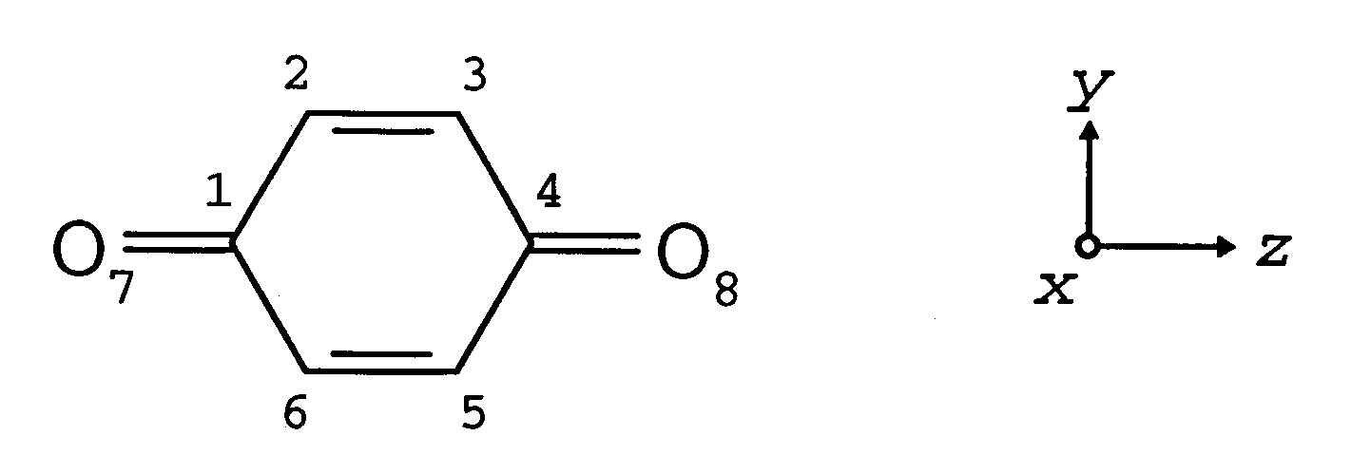

p-Benzoquinone is a yellow crystalline compound, which can be considered as the parent compound for a large group of substances, comprising many naturally occurring dyes and biologically active compounds. The most important chemical property of p-Benzoquinone is the ability to act as an oxidant (electron acceptor), which can be explained by the presence of an unoccupied π∗ molecular orbital with low energy. In this problem we consider the π electron system of p-benzoquinone within the framework of the Hückel model

- What is the symmetry point group of the molecule?
- Write the Hückel secular equations for p-benzoquinone (the equations must not be solved). The Coulomb α_{O} is taken as α_{O} = α + 2β and the resonance integral β_{CO} as β_{CO} = $\sqrt{2}$β, where α and β are the usual Hückel parameters for conjugated hydrocarbons.
- Below are given the molecular orbitals ψ_{i} = Σ_{μ} c_{μ i} p_{μ}. and molecular energies ε_{i} resulting from solution of the secular equations in question b). Indicate the shape of the orbitals and determine their symmetries (irreducible representations).
ε₋₄ = α − 2.18 β, ψ₋₄ = −0.44 p₁ + 0.38 p₂ − 0.38 p₃ + 0.44 p₄ – 0.38 p₅ + 0.38 p₆ + 0.15 p₇ – 0.15 p₈
ε₋₃ = α − 1.41 β, ψ₋₃ = −0.58 p₁ + 0.24 p₂ + 0.24 p₃ – 0.58 p₄ + 0.24 p₅ + 0.24 p₆ + 0.24 p₇ + 0.24 p₈
ε₋₂ = α − 1.00 β, ψ₋₂ = 0.50 p₂ − 0.50 p₃ + 0.50 p₅ – 0.50 p₆
ε₋₁ = α + 0.32 β, ψ₋₁ = 0.42 p₁ + 0.31 p₂ − 0.31 p₃ – 0.42 p₄ – 0.31 p₅ + 0.31 p₆ – 0.35 p₇ + 0.35 p₈
ε₁ = α + 1.00 β, ψ₁ = 0.50 p₂ + 0.50 p₃ – 0.50 p₅ – 0.50 p₆
ε₂ = α + 1.41 β, ψ₂ = 0.16 p₁ + 0.40 p₂ + 0.40 p₃ + 0.16 p₄ + 0.40 p₅ + 0.40 p₆ − 0.40 p₇ – 0.40 p₈
ε₃ = α + 2.86 β, ψ₃ = 0.36 p₁ + 0.09 p₂ − 0.09 p₃ – 0.36 p₄ − 0.09 p₅ + 0.09 p₆ + 0.59 p₇ – 0.59 p₈
ε₄ = α + 3.00 β, ψ₄ = 0.38 p₁ + 0.19 p₂ + 0.19 p₃ + 0.38 p₄ + 0.19 p₅ + 0.19 p₆ + 0.54 p₇ + 0.54 p₈

- Indicate the three lowest excited electron configurations for the π, corresponding to the ground configuration and the two lowest excited π electron configurations. What are the symmetries of the wavefunctions for these configurations? On the basis of symmetry properties, what can be said about transition moment directions and intensities for transitions from the ground configuration to the two excited π-π∗ configurations?
(opgaven fortsættes)

(Juni 2004)

- The near-UV absorption spectrum of p-Benzoquinone displays two absorption bands with maxima at 240 and 278 nm (n-hexane, room temperature). The two bands have widely different intensities: ε_{max} at 240 nm is 21500, while ε_{max} at 278 nm is only 350. Suggest on the basis of intensity and energy criteria an assignment of the two observed bands to the two π-π∗ transitions mentioned in question d).
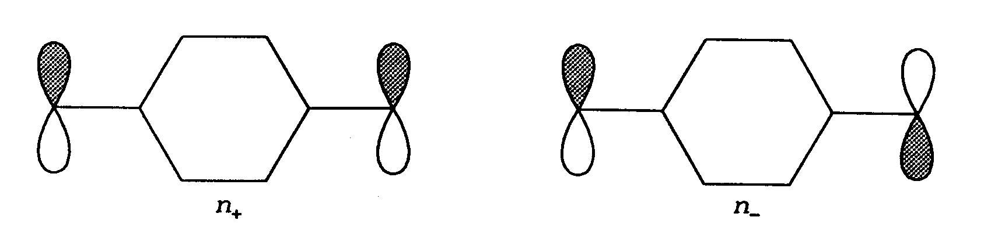
- p-Benzoquinone is a coloured compound. This is due to a band system in the visible region around 450 nm with extremely low intensity (ε_{max} ≈ 20). This band system can be assigned to transitions to n-π∗ configurations involving excitation of electrons from the n-orbitals of the carbonyl groups to the low-energy π∗ orbital ψ₋₁ (LUMO). The two n-molecular orbitals of p-Benzoquinone, n₊ and n₋, are indicated below (the plane of the paper is the y,z-plane). What are the symmetries of the two molecular orbitals n₊ og n₋ ? What are the symmetries of the wavefunctions for the two n-π∗ electron configurations corresponding to n₊ → ψ₋₁ and n₋ → ψ₋₁? Why is the intensity of the observed band system in the visible region so low?
- p-Benzoquinone easily accepts an additional electron in the vacant π∗ molecular orbital ψ₋₁, as mentioned in the introduction. This leads to the formation of a relatively stable radical anion, called p-benzosemiquinone. Determine by a population analysis the charge distribution in p-benzosemiquinone. Where is the negative charge localized?

