RUC, September 2006
Quantum Chemistry & Spectroscopy.

X Jan 2003 (1)
The hydrocarbon β-carotene is present in carrots and is responsible for their characteristic colour. The orange colour is due to a very strong absorption band in the visible spectral region with λ_{max} = 452 nm and ε_{max} = 152000 L mol⁻¹ cm⁻¹ (Inhoffen et al., Annalen 570, 654 (1951)):
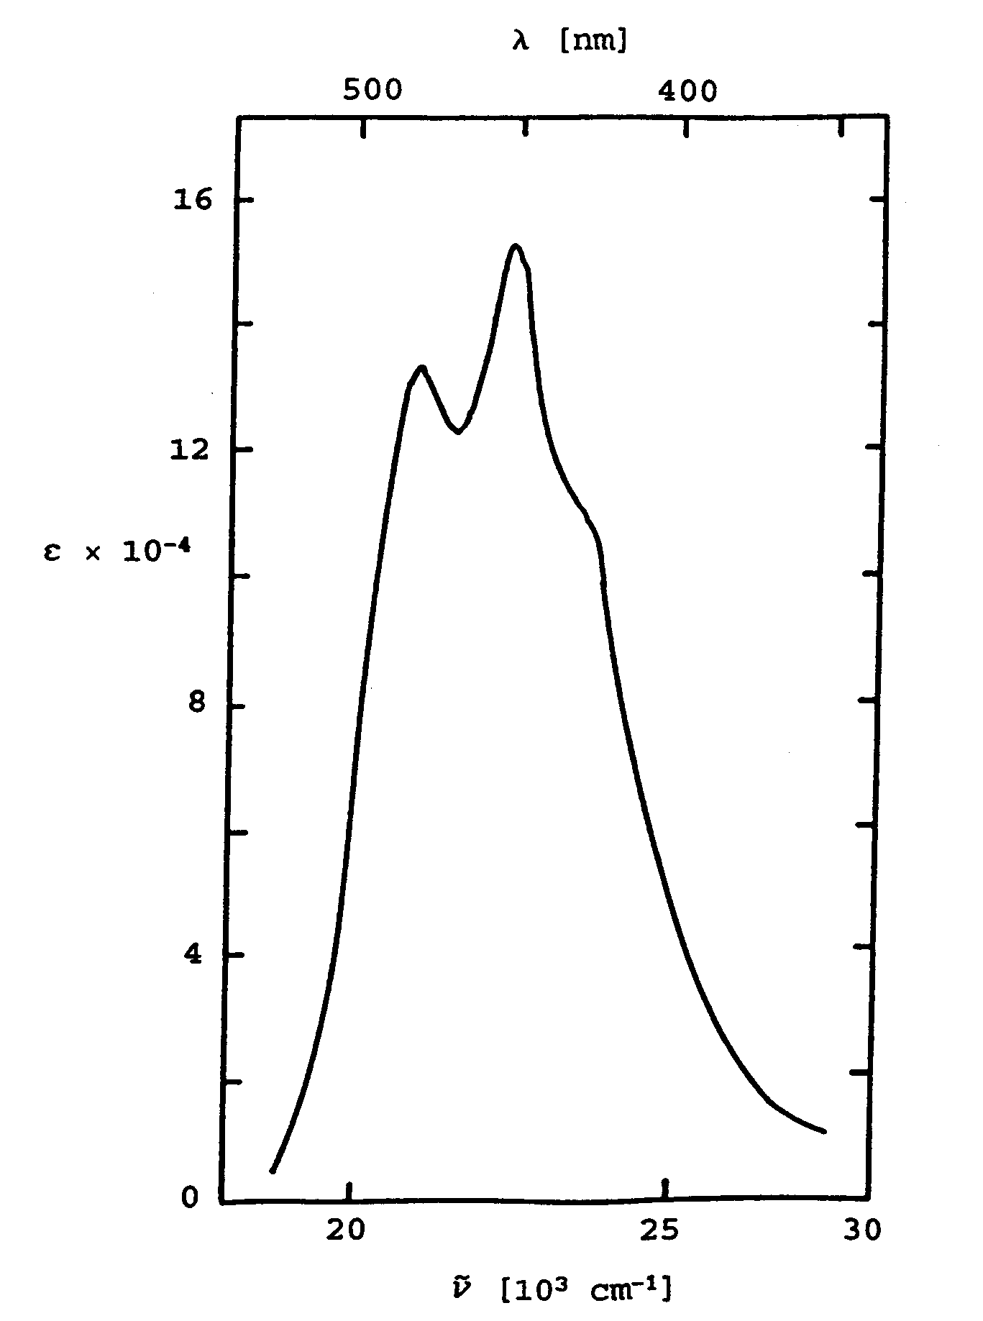

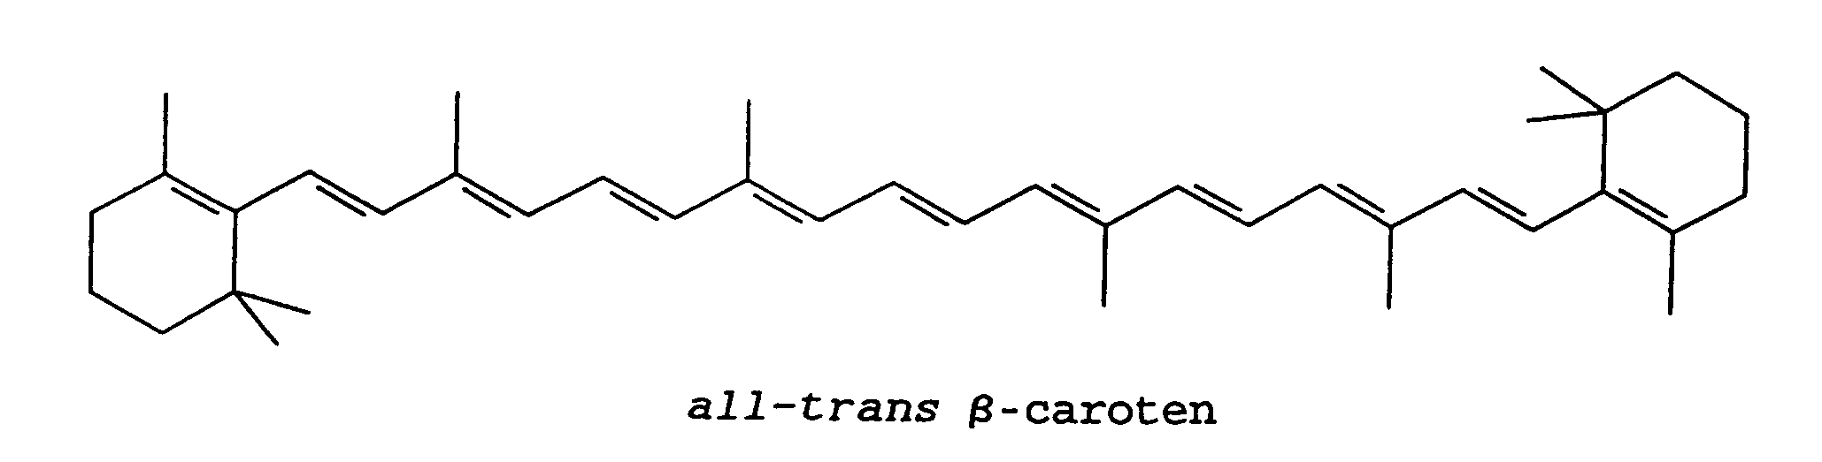

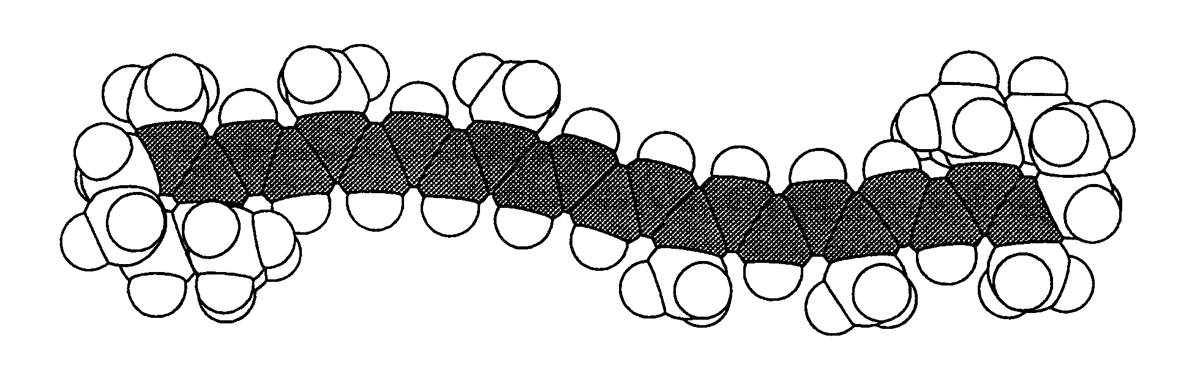

- Estimate (order of magnitude) the oscillator strength f and the length of the transition moment vector M (Debye) for the observed band.
The observed band can be assigned to a transition in the π system associated with the 11 conjugated double bonds. Assume that the transition can be described by using the “free electron model” (FEMO), where the π electrons are treated as non-interacting particles in a one-dimensional box.
- What is the effective length L of the box, if the model is required to reproduce the observed transition energy for β-carotene? Compare with the actual extension of the conjugated system (the average CC bond length can be taken as 1.4 Å).
- Predict, by using the model, the transition moment M and oscillator strength f for the transition, when the length of the box is taken as the effective value L derived in the preceding question. Compare with the observed values in question a).
Note: The transition moment M and oscillator strength f for an optical transition between the levels with quantum numbers n and n+1 in the one-dimensional box are given by the approximate relations M ≈ 2eL/π² and f(n→n+1) ≈ (4/3π²) (2n+1). (JS-L, November 2006)

