RUC, November 2006
Quantum Chemistry & Spectroscopy.

Problem 22

Because of its carcinogenic activity, benzo[a]pyrene is one of the most extensively investigated benzenoid hydrocarbons. In this problem we consider the UV-Vis absorption spectrum and the photoelectron spectrum of the compound. We shall attempt to describe the observed transitions by using the Hückel model. The relevant Hückel MO data for benzo[a]pyrene are given below:

-2 ──── ε₋₂ = α – 0.802 β A” (π*)
-1 ──── ε₋₁ = α – 0.371 β A” (π*)

1 ─┼┼─ ε₁ = α + 0.371 β A” (π)
2 ─┼┼─ ε₂ = α + 0.802 β A” (π)
3 ─┼┼─ ε₃ = α + 1.000 β A” (π)
4 ─┼┼─ ε₄ = α + 1.000 β A” (π)
5 ─┼┼─ ε₅ = α + 1.231 β A” (π)
6 ─┼┼─ ε₆ = α + 1.365 β A” (π)

- The UV-Vis absorption spectrum benzo[a]pyrene in n-heptane at room temperature shows a weak band at 24800 cm⁻¹, a strong band with maximum at 26100 cm⁻¹, and two very strong bands with maxima at 33900 cm⁻¹ and 37500 cm⁻¹ (Spanget-Larsen et al., J. Am. Chem. Soc. 114, 1942 (1992)). Estimate (order of magnitude) the oscillator strengths f of the four bands.
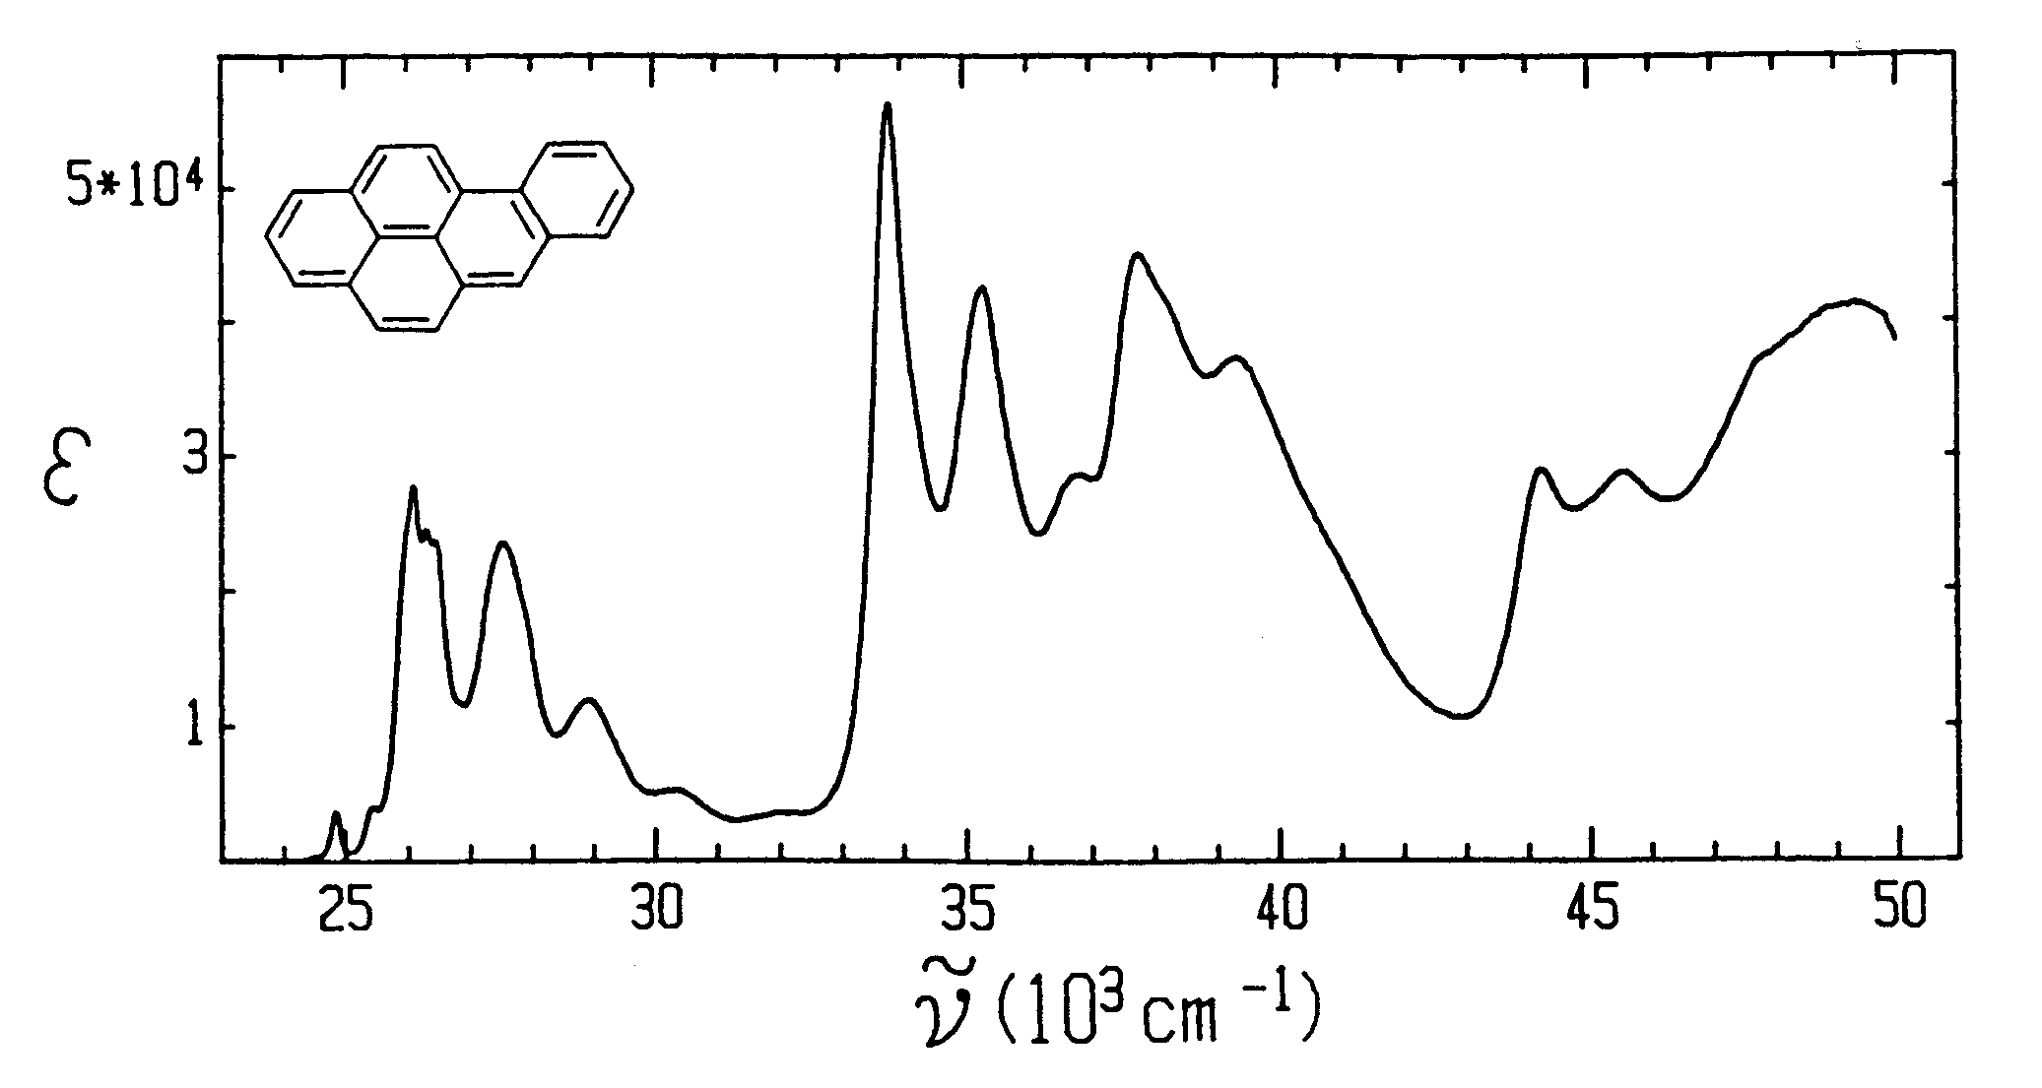

- Discuss on the basis of the Hückel data possible assignments of the observed bands to the four characteristic transitions L_{a}, L_{b}, B_{a}, and B_{b} in Platt’s nomenclature. Suggest effective values of the parameters Λ and β (see, e.g., “Laboratorieøvelser i Optisk Spektroskopi”, N.5 – N.6.
- The photoelectron spectrum of benzo[a]pyrene in the gas phase at 145 ºC has sharp peaks at 7.12, 8.00, 8.73, 8.92, 9.49, and 9.95 eV, corresponding to the ionization energies I₁ – I₆. (Boschi et al., Discuss. Faraday Soc. 54, 116 (1972)). These peaks can be assigned to ejection of electrons from the 6 highest occupied π MOs. Determine on the basis of a correlation of the observed ionization energies I_{i} with the theoretical MO energies ε_{i} (Koopmans’ theorem) effective values for the Hückel parameters α and β corresponding to the photoelectron spectrum.
