RUC, November 2006
Quantum Chemistry & Spectroscopy.

Problem 19

Hexachlorocyclohexane (HCH), C₆H₆Cl₆, is known in many isomeric forms. A mixture of different isomers is produced by addition of chlorine in sunlight or ultraviolet light to benzene. One of them, the so-called γ-form (γ-HCH, Lindan), is an efficient insecticide.

In this problem we consider the IR spectra of four HCH isomers, α-, β-, γ-, and δ-HCH. The spectra are shown overleaf: Each panel displays the IR transmission spectrum on the top and the Raman spectrum on the bottom. We only consider the IR data.

- What are the symmetry point groups of the four isomers? – Note that the structural formulas shown with the spectra are so-called Haworth-formulas with planar cyclohexane rings. They do not give a correct picture of the shape and symmetry of the molecules, but should be “translated” to the proper cyclohexane chair-conformations. Molecular models are useful!
- It is evident that the spectrum of β-HCH shows much fewer bands than the spectra of the other three isomers. Offer a qualitative explanation for this observation!
- How many normal vibrations has β-HCH? How many of the fundamental levels are IR active? How many of the IR active fundamentals correspond to C-H stretchings? And how many correspond to C-Cl stretchings? Suggest an assignment of the observed transitions in the IR spectrum of β-HCH to these and other vibrations (use tables of group frequencies).

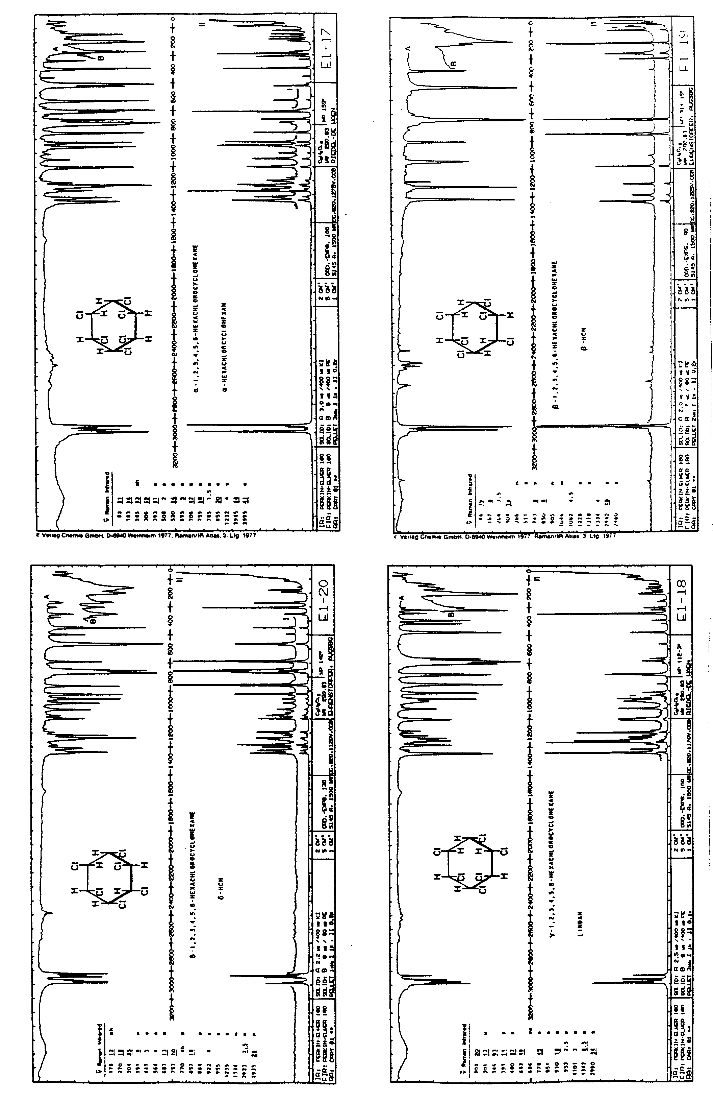
δ-HCH
α-HCH
β-HCH
γ-HCH

