RUC, November 2006
Quantum Chemistry & Spectroscopy.

Problem 18

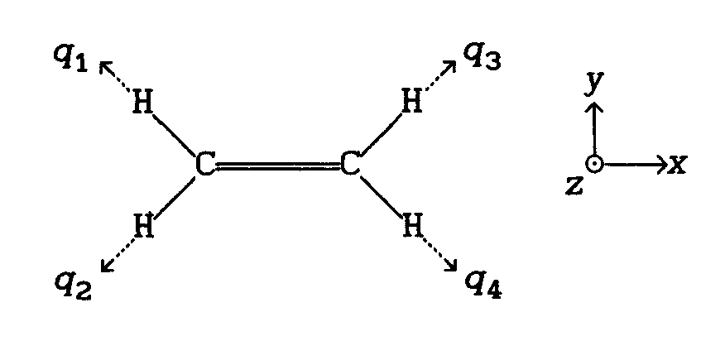

- To which symmetry point group does the ethylene molecule belong?
- What are the characters of the reducible representation Γ_{CH} spanned by the four CH-stretching coordinates {q₁, q₂, q₃, q₄}?
- Reduce the representation Γ_{CH} to four irreducible representations Γ_{i} .
- Find the four symmetry adapted linear combinations Q_{i} of the CH-stretching coordinates {q₁, q₂, q₃, q₄} that form bases for the four irreducible representations Γ_{i} . *)
The symmetry adapted CH-stretching coordinates Q_{i} describes qualitatively the four normal coordinates that are associated with the CH-stretching normal vibrations of ethylene (normal modes). In this specific example, the coordinates Q_{i} are determined by symmetry. In general, this is not the case.
- It can be shown that the vibrational wavefunction Φ(Q_{i} ) for the fundamental level of a normal mode has the same symmetry (irreducible representation) as the corresponding normal coordinate Q_{i} . Determine which of the four CH-stretching modes of ethylene that are IR active. What are their transition moment directions?
__________________________
*) A symmetry adapted linear combination that form a basis for the irreducible representation Γ_{i} can be constructed by operation of the projection operator${\hat{P}}_{i}$ on a suitable basis element:
$${\hat{P}}_{i}=\frac{1}{h}\sum_{\hat{R}}{χ_{i}(\hat{R})⋅\hat{R}}$$
where h = the order of the group
$\hat{R}$= the symmetry operations of the group
$χ_{i}(\hat{R})$= the characters of the representation Γ_{i}.

Note that${\hat{P}}_{i}$ is a weighted sum of symmetry operations; ${\hat{P}}_{i}$ is thus an operator that can act on a basis element, e.g., a coordinate or a function.

