RUC, November 2006
Quantum Chemistry & Spectroscopy.

Problem 17

Below is shown the IR absorption spectrum of gaseous sulphur dioxide, SO₂. The observed transitions are listed in the ensuing table [R.D. Shelton, A.H. Nielsen, W.H. Fletcher, J. Chem. Phys. 21, 2178 (1953)]:
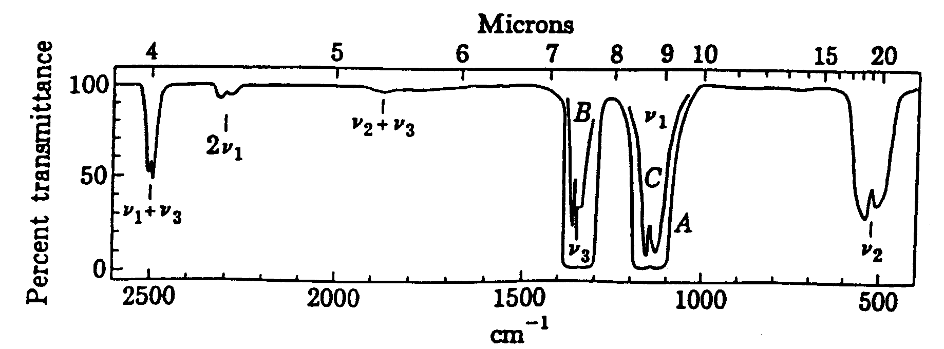

cm⁻¹ | Relative  intensity | Polarization | Assignment | Symmetry
518 | 455 | z | ν₂
845 | 0.6 *)
1151 | 565 | z | ν₁
1362 | 1000 | y | ν₃
1535 | 0.1
1665 | 0.1
1876 | 6.0
2296 | 5.5
2500 | 20.0
2715 | 0.2
2808 | 0.8
3011 | 0.02
3431 | 0.01
3630 | 0.8
4054 | 0.03
4751 | 0.006
5166 | 0.02

*) Temperature dependent.

- The intense transitions at 518, 1151, and 1362 cm⁻¹ can be assigned to three IR active fundamental levels (ν₁-₃). Decide on the basis of symmetry arguments whether the molecule is linear (D_{∞h}) or angular (C_{2v}):

D_{∞h} C_{2v}

- Suggest an assignment of the three fundamental transitions to stretching and bending vibrations (the stretching frequency of a bond is generally about twice as large as the corresponding bending frequency). What are the symmetries (irreducible representations) of the three vibrations?
- Try to assign the remaining (weak) peaks in the spectrum to hot, overtone, or combination bands, with indication of symmetries and polarization directions.

