RUC, November 2006
Quantum Chemistry & Spectroscopy.

Problem 16

The free allyl radical CH₂=CH–ĊH₂ is a very reactive species, but in 1983 Maier et al. (Chem. Ber. 116, 732) succeeded in isolating it in an argon matrix at 10 K. The UV spectrum of the radical exhibits a weak absorption band around 400 nm and a strong transition at 213 nm. The intensity ratio between the two bands is 1:200.
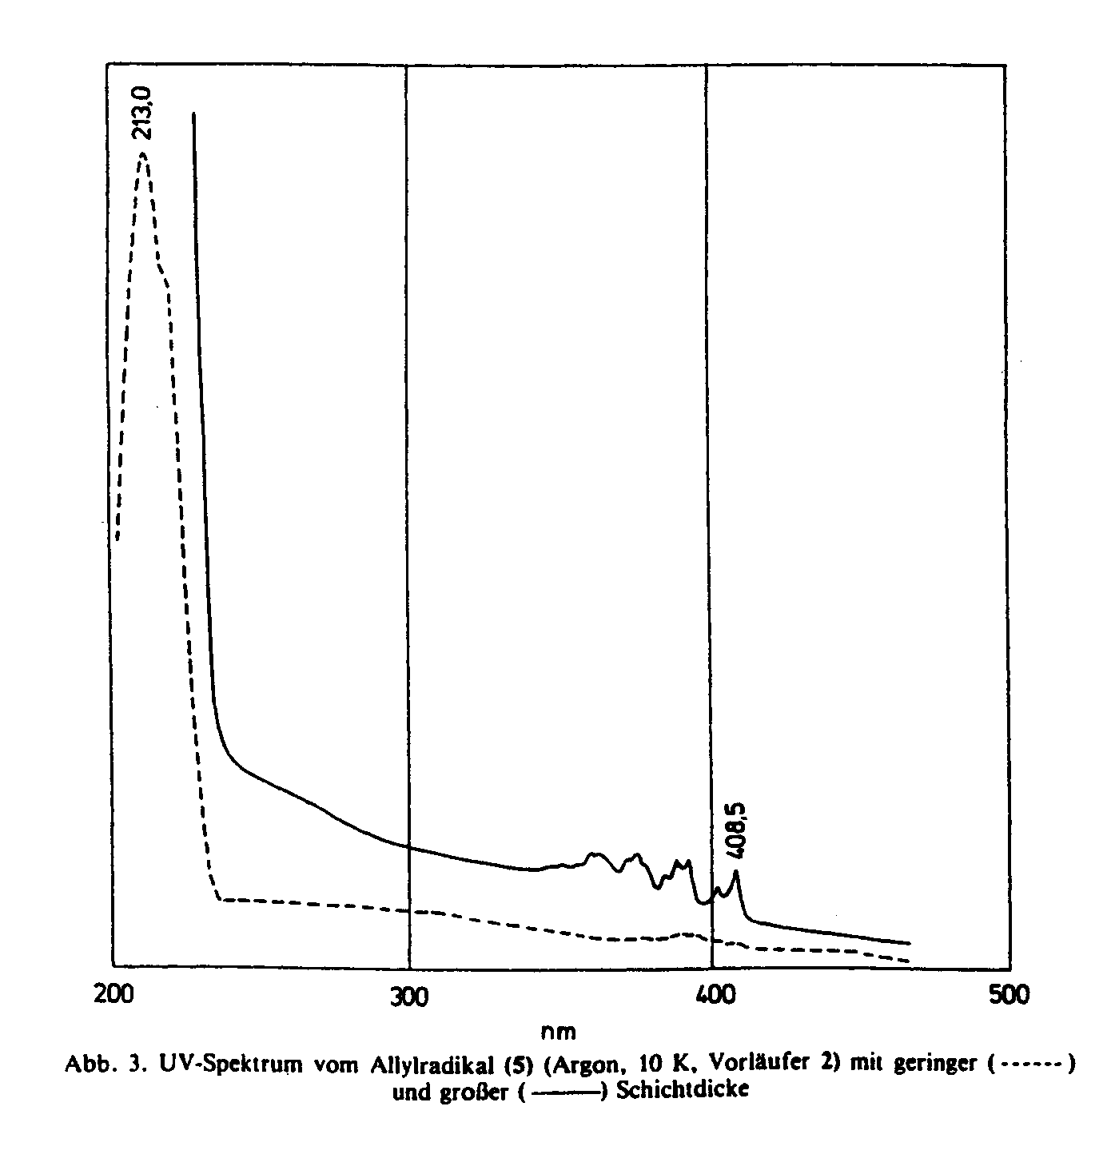

The π-electron system of the allyl radical is frequently described by the resonance formalism, corresponding to a delocalized, C_{2v} symmetrical molecular structure:

In this problem we apply the Hückel model in a description of the π-electronic structure of the allyl radical and its π−π* electronic transitions.

- Show that the Hückel energies ε and the molecular orbitals ψ are given by
ε ₋₁ | = | α | – | $\sqrt{2}$β, |  | ψ ₋₁ | = | (1/2) | p₁ | – | $$(1/{\sqrt{2}})$$ | p₂ | + | (1/2) | p₃
ε ₀ | = | α | , |  |  | ψ ₀ | = | $$(1/{\sqrt{2}})$$ | p₁ |  |  |  | – | $$(1/{\sqrt{2}})$$ | p₃
ε ₁ | = | α | + | $\sqrt{2}$β, |  | ψ ₁ | = | (1/2) | p₁ | + | $$(1/{\sqrt{2}})$$ | p₂ | + | (1/2) | p₃

- What are the symmetries (irreducible representations) of the three molecular orbitals? The ground state electronic configuration is (ψ ₁)² (ψ ₀)¹. What is the symmetry of the wavefunction Ψ_{G} for this configuration?
- The two lowest π−π* configurations can be described by the electron promotions ψ ₀ → ψ ₋₁ and ψ ₁ → ψ ₀, leading to the configurations is (ψ ₁)² (ψ ₋₁)¹ and is (ψ ₁)¹ (ψ ₀)². Their wavefunctions can be designated Ψ_{0,-1} and Ψ_{1,0} . What are the symmetries of these wavefunctions?
- Determine the moment directions for transitions from the ground state to the two excited configurations, Ψ_{G} → Ψ_{0,-1} and Ψ_{G} → Ψ_{1,0}.
- In the Hückel model, Ψ_{0,-1} and Ψ_{1,0} have the same excitation energy, ΔE = $\sqrt{2}$|β| for allyl. But in a more realistic treatment that takes explicit account of two-electron interactions, the two degenerate configurations interact and split into a “minus” state and a “plus” state, Φ– and Φ⁺, with different excitation energies, ΔE– and ΔE⁺:
ΔE⁺ = ΔE + Λ , Φ⁺ = $(1/{\sqrt{2}})$[ Ψ_{0,-1} + Ψ_{1,0} ]
ΔE– = ΔE – Λ , Φ– = $(1/{\sqrt{2}})$[ Ψ_{0,-1} – Ψ_{1,0} ]
Interaction between degenerate configurations is called first order configuration interaction (CI) and is fundamental in the description of the excited electronic states of alternant hydrocarbons (because of the alternant pairing symmetry, degenerate configurations with the same symmetry frequently occur). The splitting parameter Λ is most frequently positive, i.e., Φ– has lower energy than Φ⁺. The transition probability for the transition Ψ_{G} → Φ– is very small, whereas it may be large for the transition Ψ_{G} → Φ⁺.
On the basis of energy and intensity criteria, assign the observed electronic absorption bands to the theoretical transitions Ψ_{G} → Φ– and Ψ_{G} → Φ⁺, and derive an empirical value for the parameter Λ (eV and cm⁻¹). Estimate the magnitude of the Hückel parameter b for the allyl radical (generally, qualitative estimates of this kind lead to |β| = 3 – 4 eV).

