RUC, September 2006
Quantum Chemistry & Spectroscopy.

Problem 1
In a classical experiment carried out by the American physicist R. A. Millikan i 1916 (Phys. Rev. 7, 355), a sodium surface was irradiated with monochromatic light of different wavelengths λ and the emitted photoelectrons were analyzed according to their kinetic energy.
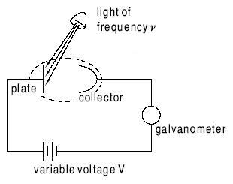

Millikan used an experimental setup where the photoelectrons hit an electrically conducting screen (collector). The energy of the emitted electrons was determined by measuring the voltage V that should be applied to the screen relative to the sodium surface in order just to stop the photoelectron current (“the stopping voltage”). The kinetic energy of the photoelectrons ½mv² (Joule) is equal to e⋅V, where e is the elementary charge in Coulomb and V is the stopping voltage (note that 1 Joule = 1 Coulomb Volt). The following values of wavelength λ and voltage V were measured (1 nm = 10⁻⁹ m):

λ (nm) | V (Volt)
312.5 | 2.128
365.0 | 1.595
404.7 | 1.215
433.9 | 1.025

Photoelectron data like these lead to the first precise determination of Planck’s constant h
(± 0.5%). Derive a value of Planck’s constant from Millikan’s data, and determine the electronic binding energy (ionization energy, work function) in eV for the metallic sodium sample applied in his experiment.

