Organic Chemistry. Test Friday August 23 2013

You have 2.5 hrs. to solve 7 problems on 3 pages. Mobile phones are not allowed. Turn your mobile phone off! All books and notes are allowed. Mark each sheet with 1/N, 2/N etc.out of N. Remember to mark your sheets with name or CPR number

Problem 1 (15%)
Draw structures corresponding to the following names:
- 2-Cyanoheptanoic acid
- N-Phenylacetamide (N-Phenylethanamide)
- cis -1,2-dihydroxycyclobutane
- 3-Nitrotoluene
- (Z)-2-fluoro-3-ethyl-2-hexene

Problem 2 (30%).
A compound A when burned gives a flame full of soot.
A is heated with sodium and the reaction mixture is destroyed with water. The reaction mixture is filtered and to the filtrate is added a few drops of FeSO₄ and HCl. An intense blue colour is seen.
Hydrolysis of A yields two new products B and C.
Compound C gives an acidic reaction when dissolved in water.
Compound B is dissolved in HCl and sodium nitrite is added. When β-napthol in sodium hydroxide is added a red dye is formed.

The MS of the compound looks as follows:

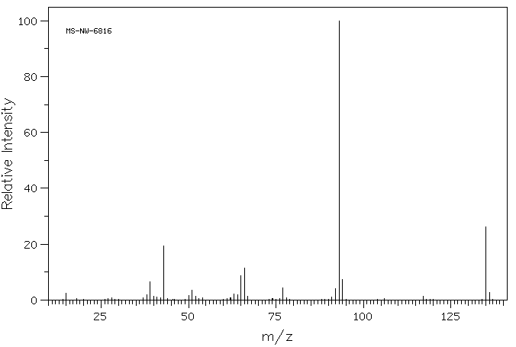

Elemental analysis gave: C 71.11%; H 6.67% and N 10.37%
Give a structure based on the results above. To help you solve the problem write the reactions involved.

Problem 3 (16%).
- Identify with name the functional groups and the type (primary, secondary, tertiary or quaternary when appropriate)

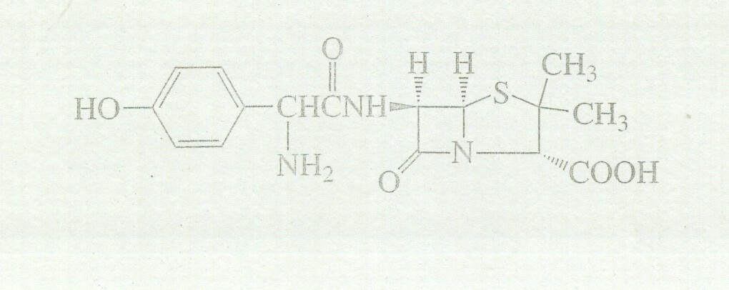

- Identify the centres of chirality.
- How many stereoisomers are possible?

Problem 4 (16%).

Write structures corresponding to the formula C₃H₅NO₂. Among the structures must be both linear and cyclic structures. The following functional groups should be present: ketone, alcohol, amine, amide, nitrile, C-C double bond, nitro group, ether and ester. If the compounds can be either cis or trans, or E/Z indicate this.

Example: carboxylic acid and imine

Problem 5 (9%).

Write tautomeric structures of
a)
b) c) hint: this is an optically active derivative of ibuprofen formed in the liver. If the tautomerism takes place then the derivative loses its optical activity.

Problem 6 (9%).

- What is the resulting compound when water is added to the compound using aconitase

b ) What is the product when
is oxidized

- What is the product when
- is reduced using NADH

Problem 7 (5%).
Which is more oxidized in the following pairs if any difference exist (argue)

