China Can Decrease Leverage by Levying Real Estate Tax
Received: December 5, 2018, Changed: December 7
In recent years, the high non-governmental debts in China, i.e., high debts of enterprises and residents with an increasing leverage, have received extensive attention at home and abroad. Elementary arithmetic teaches us, that external debts can be benign for the country when (i) the involved companies are expanding and can make productive use of the loans, and (ii) when the earnings of the application of the loaned capital surpasses the costs of the loan, i.e., when the interest rate of the loan is below the rate of return of the chosen applications – and remains so at least as long as the redemption will take. It is indisputable that leverage can work in two directions. It can increase earnings and make better running companies and better private life, and it can work in the opposite direction, ruin companies and make private life miserable.

High debts are very risky for each single company, household and for the country. High debts may trigger a financial crisis when the expenditures for the loans come to surpass the return, e.g., when the interest rate increases substantially or the path of economic activity slows down. Moritz Schularick (2010) found that “credit growth is a powerful predictor of financial crises” from a database of 14 high-income countries. How to solve the problems of high debts and decrease leverage is a pressing matter now.

From 2014 to 2017, the banks in China issued monetary credit of 100 trillion RMB. But how much GDP increment has it created? Only 17 trillion RMB! A large amount of monetary resources were squeezed into real estate, pushing up housing prices to double. Money issuance is to promote economic growth and generate new output. If money issuance is ineffective, it is excess money. As a result, the total market value of Chinese real estate reached 450 trillion RMB (65 trillion US dollars), about 10 times the total market value of Chinese A shares of 41.6 trillion RMB (6 trillion US dollars) by November 2018.

As of the end of June 2018, the balance of housing loans of 26 A-share listed banks summed up to 25.92 trillion RMB, accounting for nearly 31.4% of the total of granted loans of these banks that were open at that time. Among those, the total amount of personal housing loans exceeded 20.7 trillion RMB, an increase of 7.52% from the beginning of the year. The balance of real estate loans under corporate loans exceeded 5.2 trillion RMB, an increase of 8.34% from the beginning of the year.

The high debt ratio of Chinese households and real estate companies is related to the real estate bubbles.. If the real estate bubble is not eliminated, it is difficult to reduce the high debt ratio and eliminate the financial risk. The real estate and bank credit are naturally linked. Banks provide funds for both supply and demand sides of real estate.That has created a high leverage in the real estate industry. Without adjustment in housing prices, deleveraging is difficult to sustain.

What measures are conducive to reducing housing prices? We recommend the implementation of real estate tax. It is actually helpful to reduce the pro-cyclicality of the financial cycle, i.e., to reduce the amplitude of financial variables’ fluctuations during the credit cycle of the expansion and contraction of access to credit over time: If we have a real estate tax and no land-transferring fees, in fact, we rely less on fiscal and more on finance, which is conducive to reducing the pro-cyclicality of finance. Lowering the actual housing prices (i.e., to pay once, namely when acquiring a flat) by introducing a new permanent, but affordable burden (by an annually continuing real estate tax) is the key to deleveraging.

Only by lowering leverage can we avoid the financial crisis for companies, private households, sectors of the economy or the whole country. (The following two figures show the relative normal leverage ratio of China's real economy and the exceptionally high leverage ratio of China’s enterprises.) In the long run, it seems to us, it is important to ensure the security of the financial system, rather than focusing on maintaining high housing prices in China's big cities.

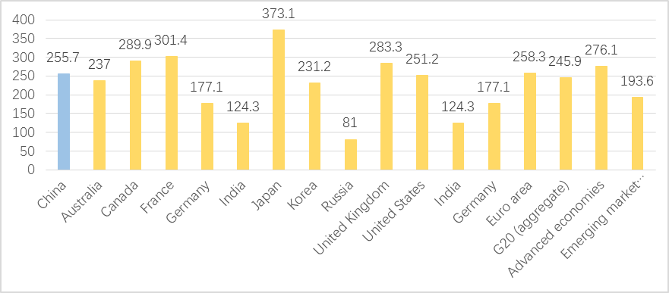

Fig. 1 International comparison of leverage ratio [in %] of China's real economy (end of 2017)
Source: Bank for International Settlements (BIS)

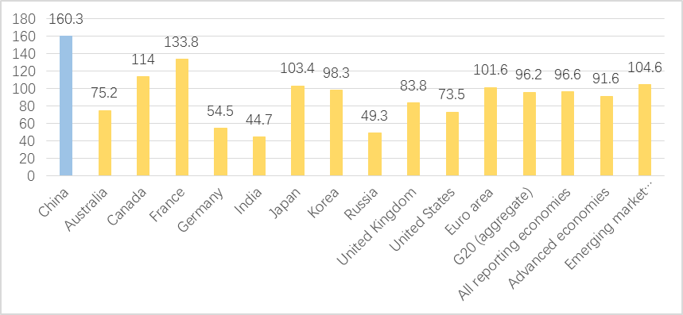
Fig. 2 International comparison of leverage ratio of Chinese enterprises (end of 2017)
Source: Bank for International Settlements (BIS)

However, how to establish a real estate tax system suitable for China, determining the specific tax rate and the amount of reduction and exemption? That task will not be easy. First, we need to deal with the relationship between real estate tax and land-transferring fees. Land in China is divided into collective land and state-owned land. State-owned land is owned by the state. Land auctions do not grant land ownership, but land use rights, and grant a certain number of years (mostly 70 years). The important motivation for the Chinese government, especially local governments, to develop real estate comes from China's tax system. A key source of revenue is land-transferring fees, which is levied during the transfer of state-owned land to developers. Taxes on real estate development and apartment sales also contribute to local fiscal revenue. The present land finance has “kidnapped” Chinese economy and local governments to some extent. In some years, land sales accounted for 40% of local government revenue. Transforming land-transferring fees into the real estate tax levied by stages will remove the dependence of local governments on the land-transferring fees.

In the long run, the levy of real estate tax is a new addition to the government's income for special purposes. Real estate tax is the general direction of social progress. Developed countries in Europe and the United States have implemented real estate tax systems. Local government finances are up to 60% dependent on real estate taxes. At present, there are not a few people in China who advocate real estate tax, but the levy of real estate tax on the premise of not abolishing the land-transferring fees. It would be a double taxation. Such a tax does not have legitimacy, which is why it is difficult to generate a true consensus regarding real estate tax at present. Legal steps will be necessary to replace the land-transferring fees by a suitable real estate tax.

First, in the total value of real estate, the value of the house itself is small. A considerable part of the real estate value is the land-transferring fees. From a financial point of view, the land-transferring fees is the capitalization of the real estate tax in the next 70 years. It is the one-time collection of all the real estate taxes in the next 70 years by discounting. This kind of capitalization strengthens the financial attribute of the real estate (Peng,2018). Assuming that the land-transferring fees is zero, the government would collect several thousand RMB of real estate tax a month per item, and the corresponding house price would probably be affordable to many young people today. But now one-off capitalization has become a one-off transaction price, and many young people can't afford it. They have to rely on external financing. This undoubtedly increased the debt ratio of Chinese families.

The actual building cost in China is quite low. By 2014, China's Engineering Cost Network showed that the cost of multi-storey housing per square meter was 1,362 RMB, and that of high-rise housing was 1,817 RMB per square meter, or $19 to $26 per square foot, which is surprisingly low compared with the US standard. The China Real Estate Yearbook estimates slightly higher, at 2,730 RMB per square meter, or about $38 per square foot, but that includes hardware costs and other additional costs. The key to implementing real estate taxes is separating the value (and price and ownership) of the land and of the “bricks”. What we mean is that the buyer of a flat pays a fixed sum for the bricks and installations when buying, but pays perpetually for the land use on an annual basis, as with the substantial annual ground tax levied in Scandinavian countries.

Second, a good real estate tax system should balance the interests of all parties, including government, banks, developers and residents. A good tax policy design is the key to continuous operation of real estate tax. This tax rate must ensure that the government receives the same amount of revenue as the previous land grant so as to have the initiative to levy. In order to stabilize housing prices, the government must impose a relatively high real estate tax. If the real estate tax is set too low, it does not play a role in regulating housing prices.

Good housing tax relief measures are conducive to the reform of the supply side of the real estate market and the establishment of a long-term mechanism for price control in the real estate market. The role of real estate tax on the market should be long-term and sustainable. It can adjust the housing needs of different income groups quantitatively, so as to adjust supply and demand rationally. At the same time, it increases the revenue of local governments, which makes local governments more active in levying taxes. When there is no land to sell, local government also has a tax revenue to provide better public goods and services for the people of the community.

We think the real estate tax levy is not simply to introduce a tax, in fact, it is a matter of great institutional transformation. The purpose of introducing real estate tax is not only to replace the land finance, but also to narrow the gap between the rich and the poor. So it is wrong to tax all residents. Through the establishment of multi-level, diversified and rationalized real estate tax relief and preferential treatment, the policy of exemption or low tax rate for the per capita living space of specific groups will be implemented.

Third, as an important substantive element of real estate tax, the system of reduction and exemption is the key to the sustainable and sound operation of real estate tax. Real estate tax should be levied on the valuation of real estate. We should differentiate for a real estate whether the land-transferring fee has been paid or not. The real estate for which the land-transferring fee has been paid will be exempt from the real estate tax within 70 years. A value-added tax should be considered, that is, the value-added income of the real estate transferring should be taxed.

The land-transferring fees is the sum of the land rent for a number of years to be paid once, while the real estate tax is paid annually. If the price paid by the residents to purchase the house already includes the land-transferring fees, then it is obviously unfair to use this price as the basis for the annual payment of real estate tax. Therefore, a reasonable choice should consider converting the land-transferring fees that has been paid for many years into the amount of paid annually and then assessing the real estate value, or deducting it from the real estate appraisal value in a certain proportion.

